DDL AND ALL RELATED COMANDS
2520030134
KRISH SUREJA

- CREATING A TABLE bank_transaction
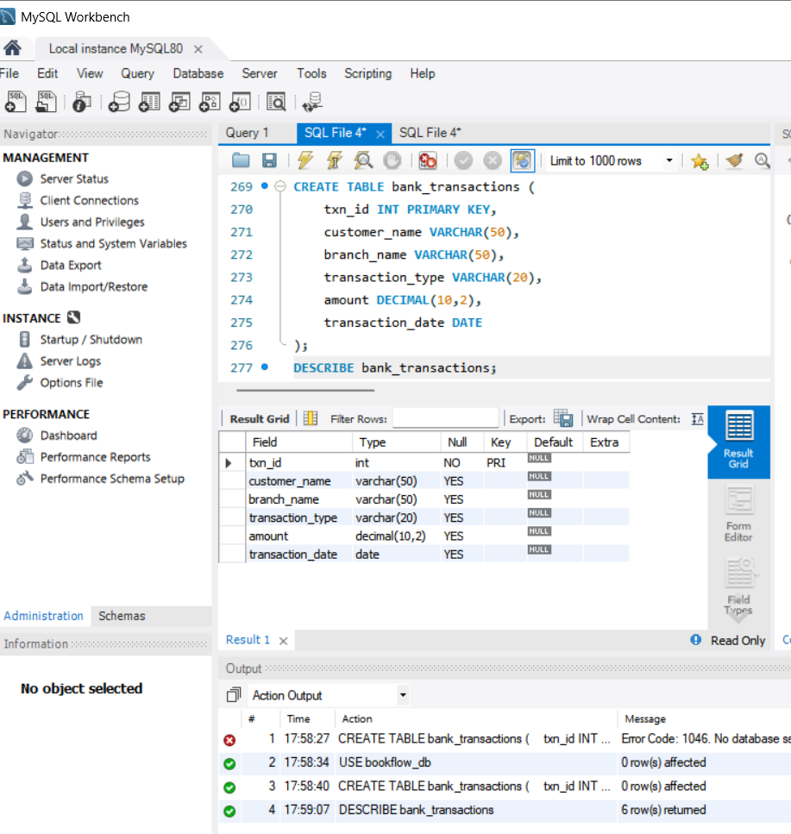

2.USING ALTER TABLE AND COLOUMN
I added acc.no coloumn

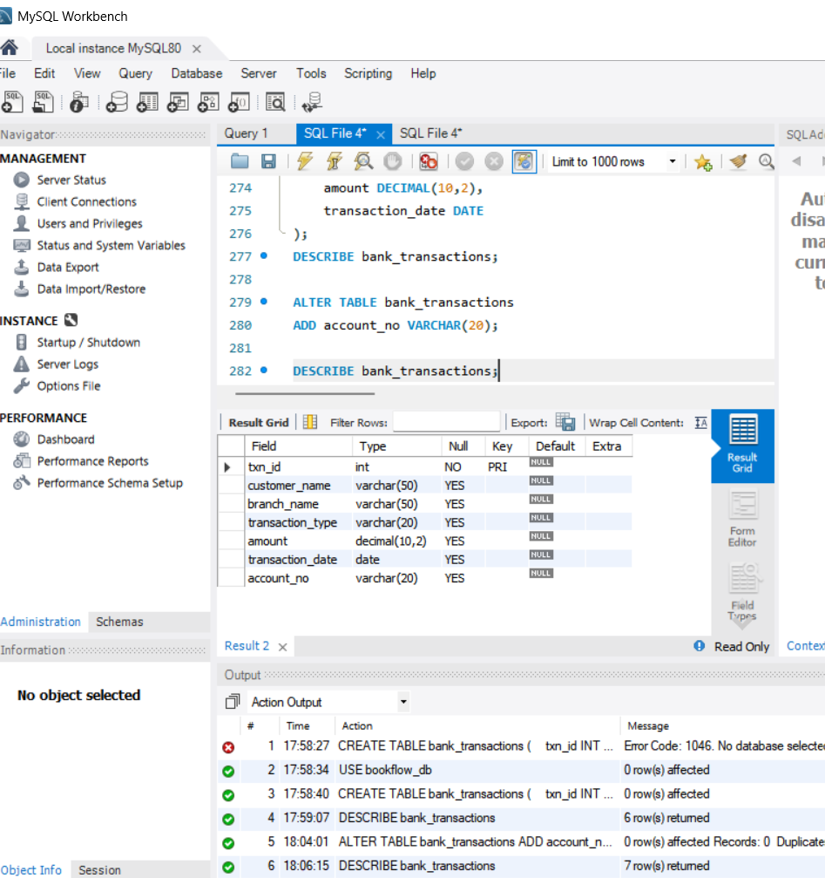

3.USING ALTER MODIFY
Modified customer name VARCHAR to 100 which was 50 previously
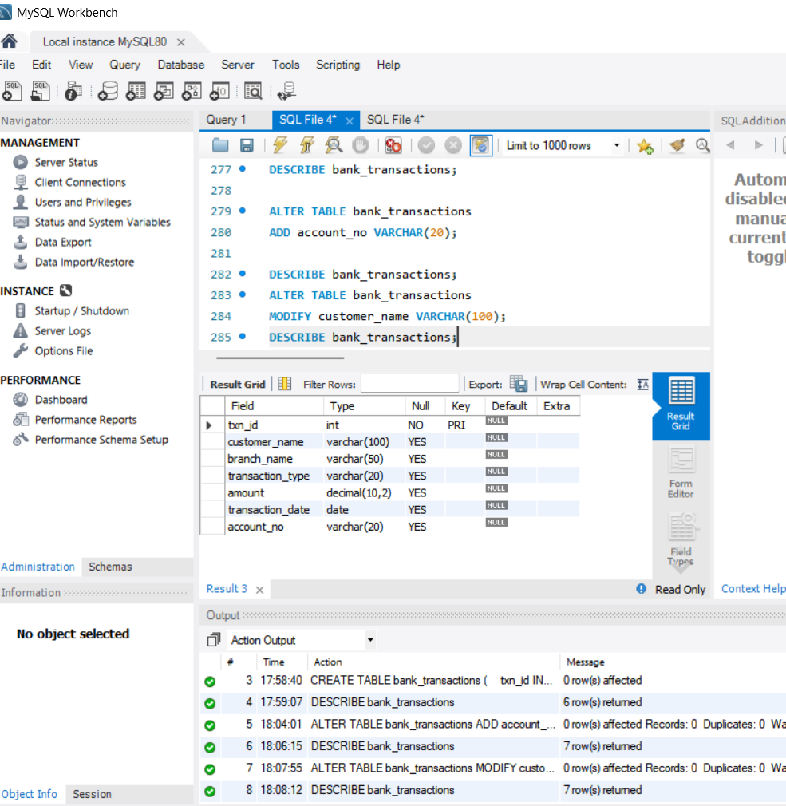

4.USING ALTER TABLE RENAME COMMAND
Name of the table is changed

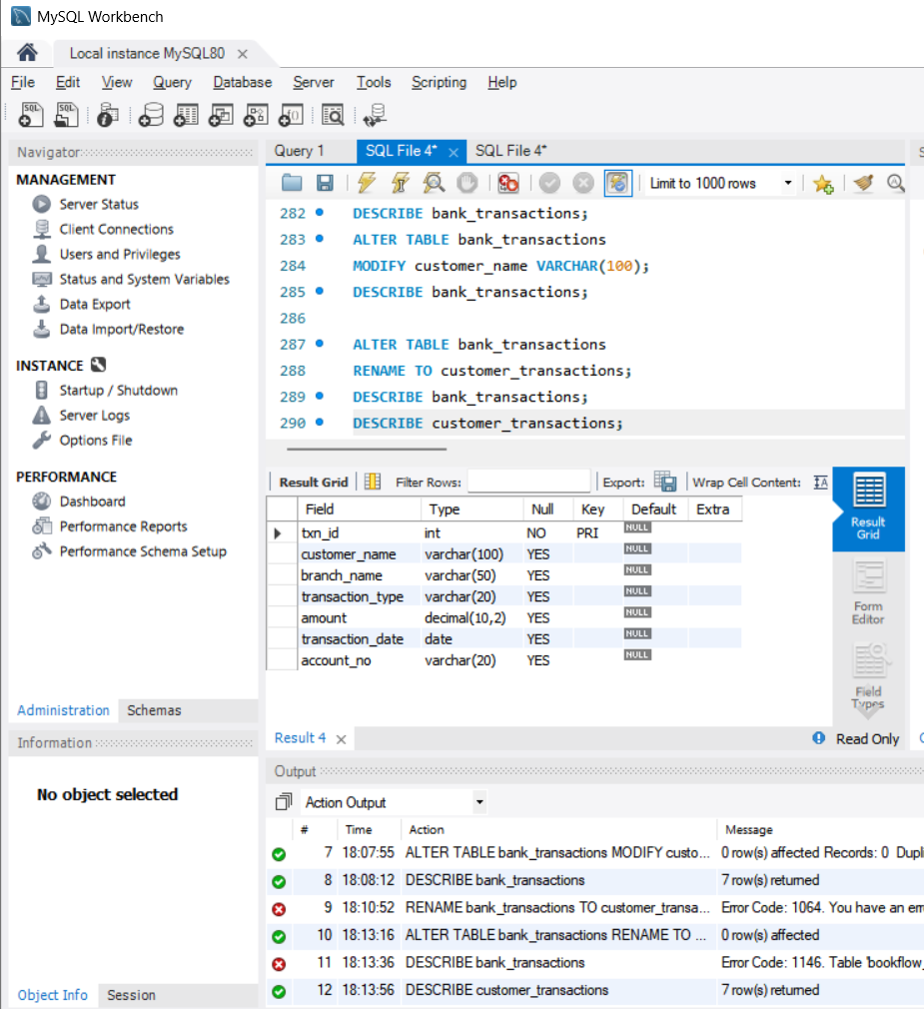

6.USING DROP TABLE
Customer_transactions table got deleted completed using DROP TABLE
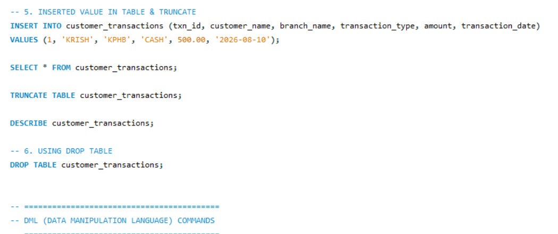

DML[DATA MANUPULATION LANGUAGE]
1.CREATED TABLE AND INSERTED VALUES

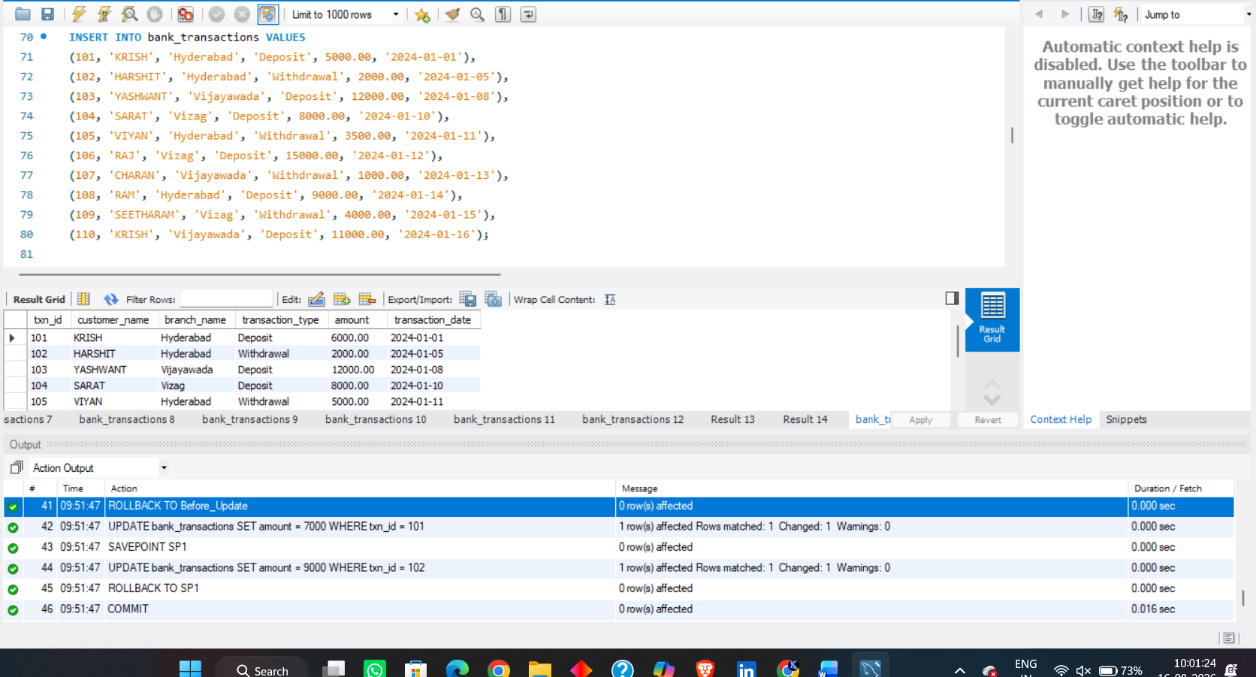

2.INSERT
Added Krishna into table
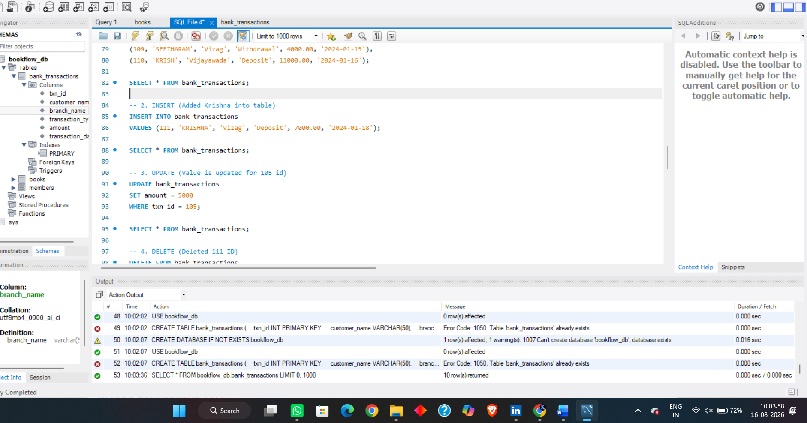

3.UPDATE
Value is updated for 105 id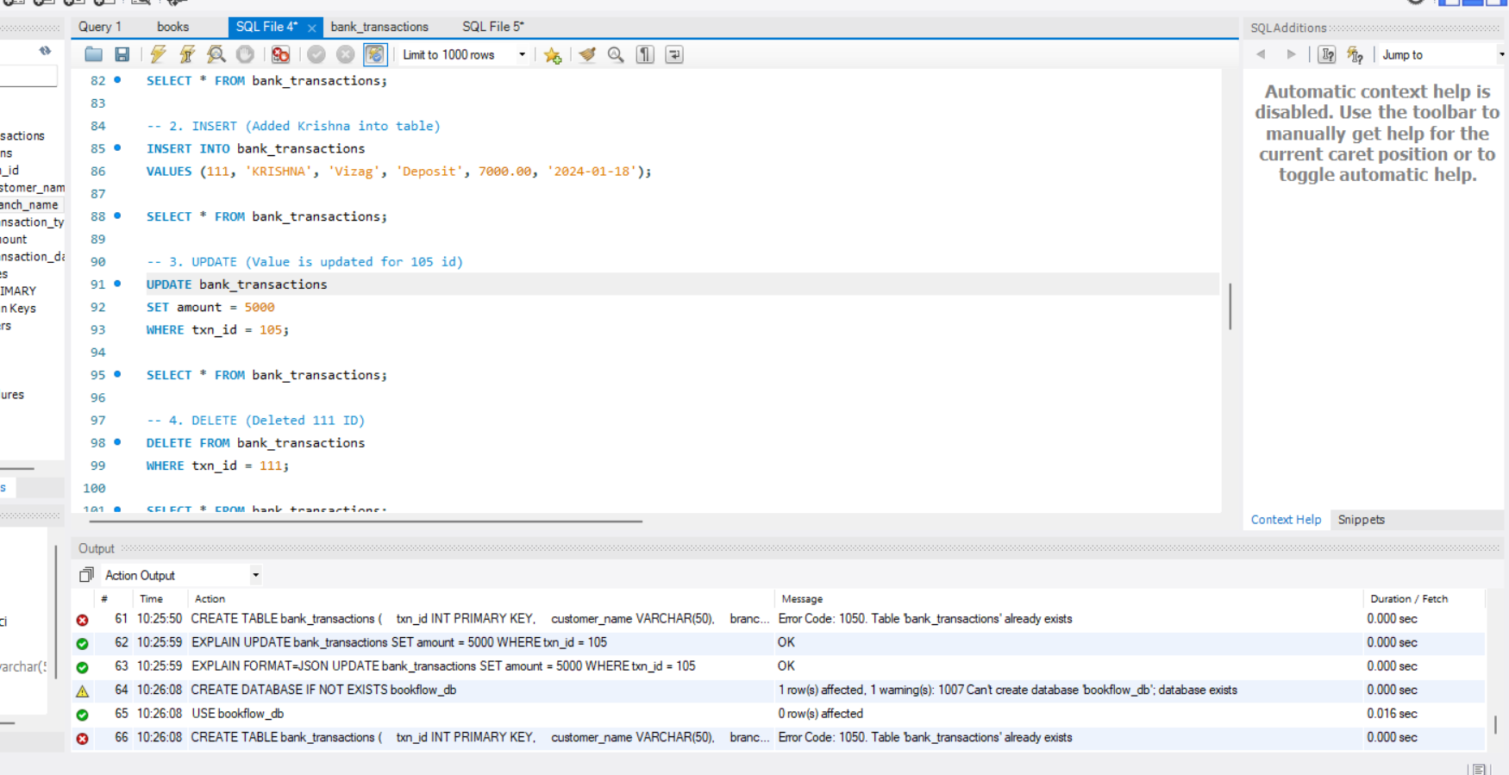

4.DELETE
DELETED 111 ID
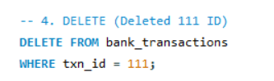

5.SELECT WITH WHERE CLAUSE
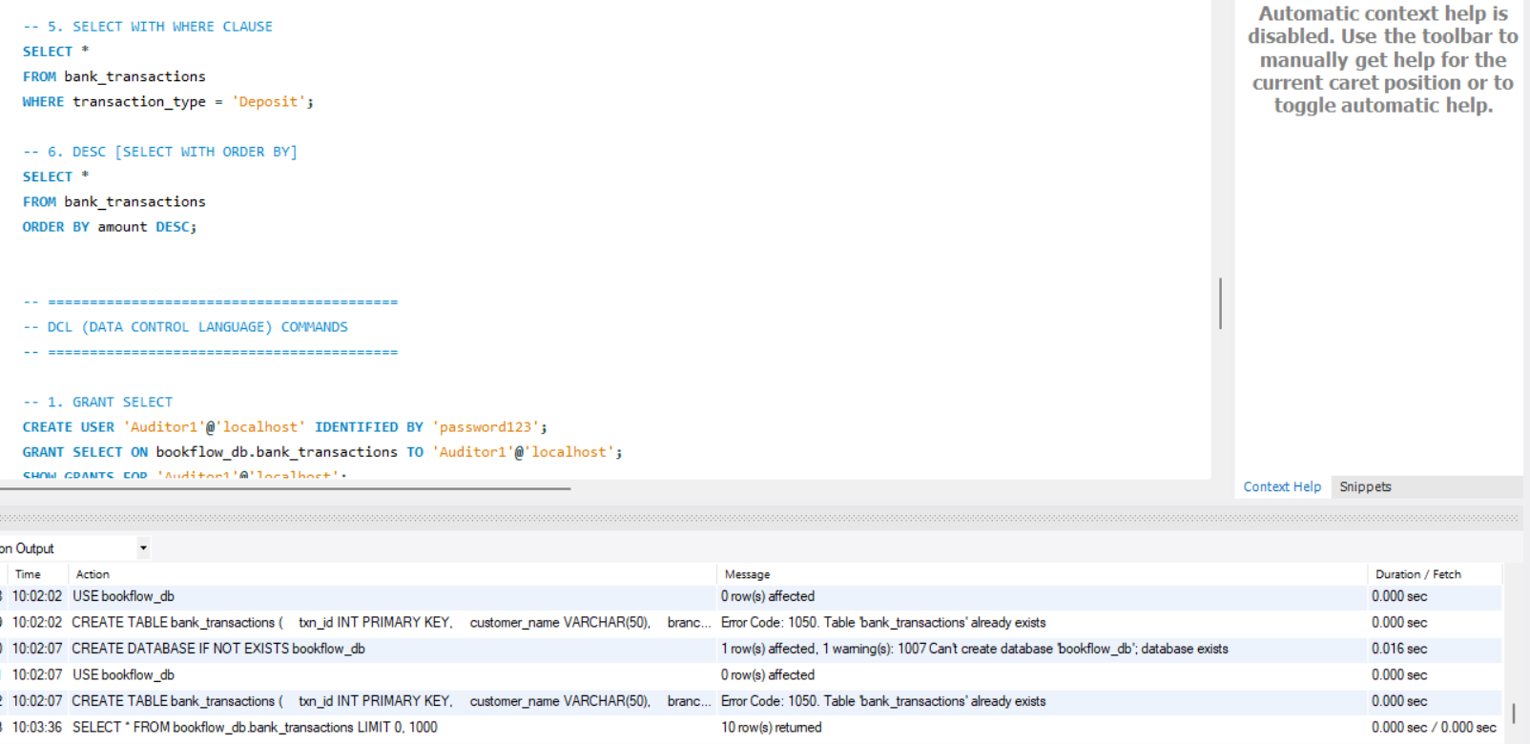

6.DESC [SELECT WITH ORDER BY]
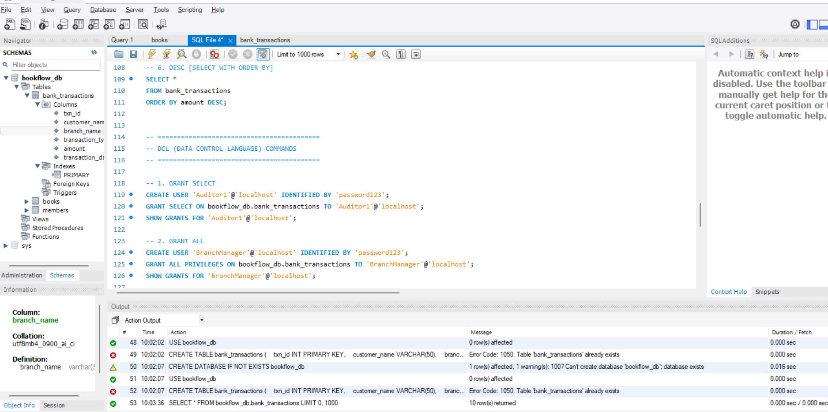

DCL[DATA CONTROL COMMANDS]
1.GRANT SELECT
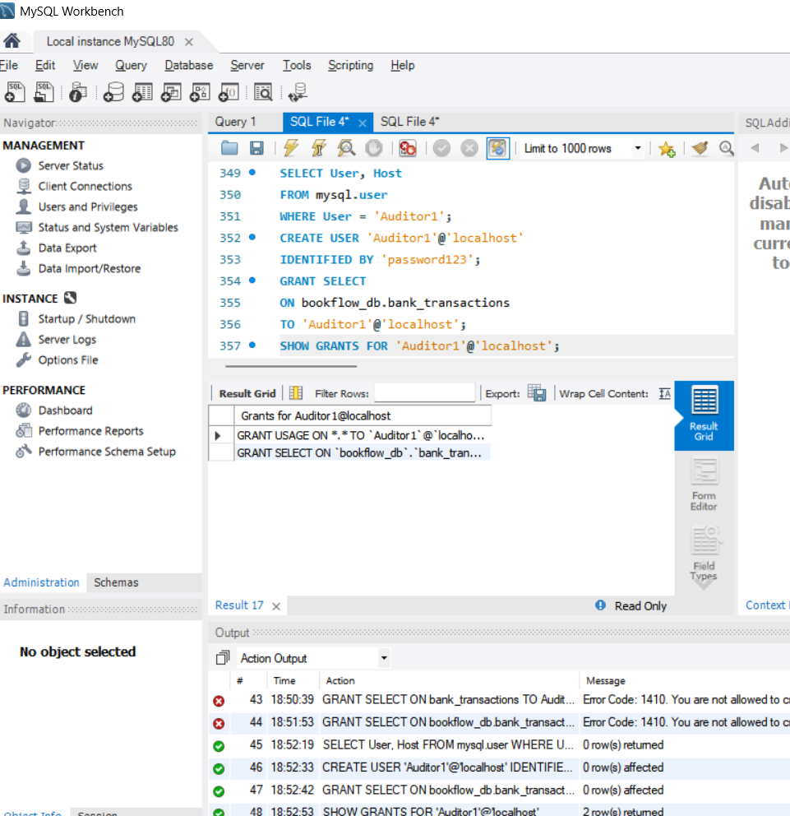

2.GRANT ALL
Granted all permissions to bank manager using grant all
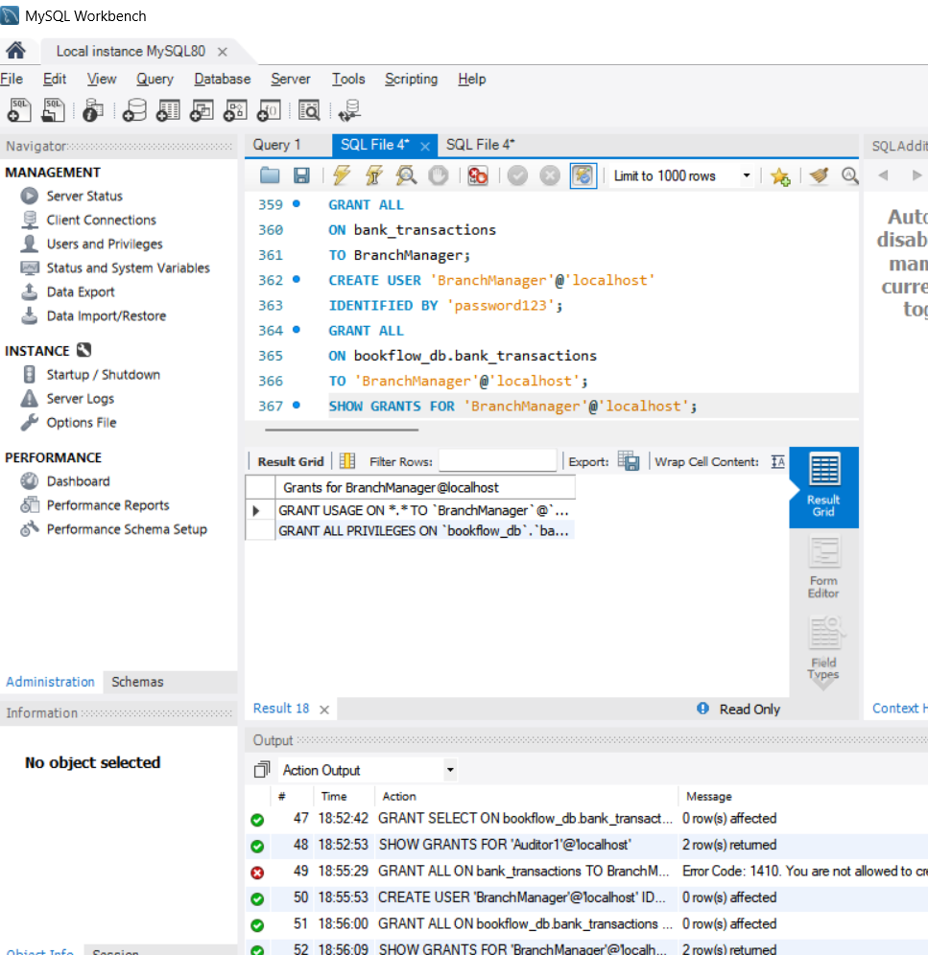

3.REVOKE SELECT
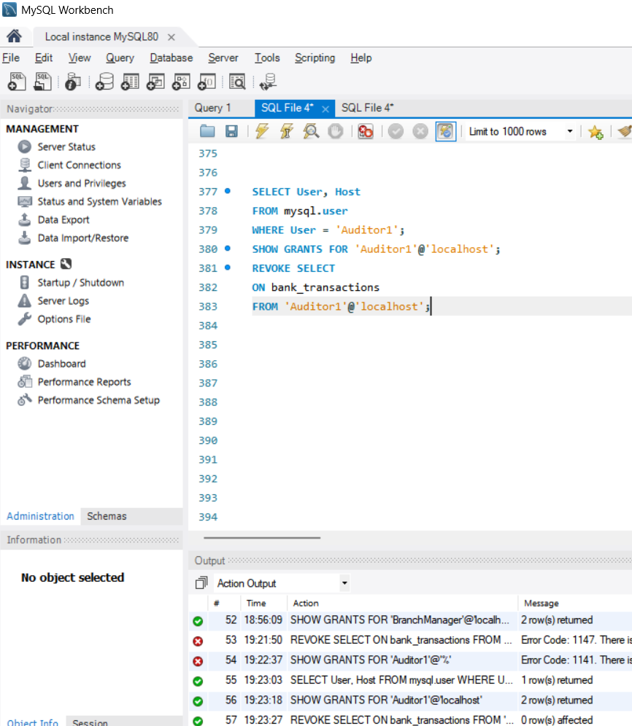

4.REVOKED ALL PERMISSIONS TO BANK MANAGER
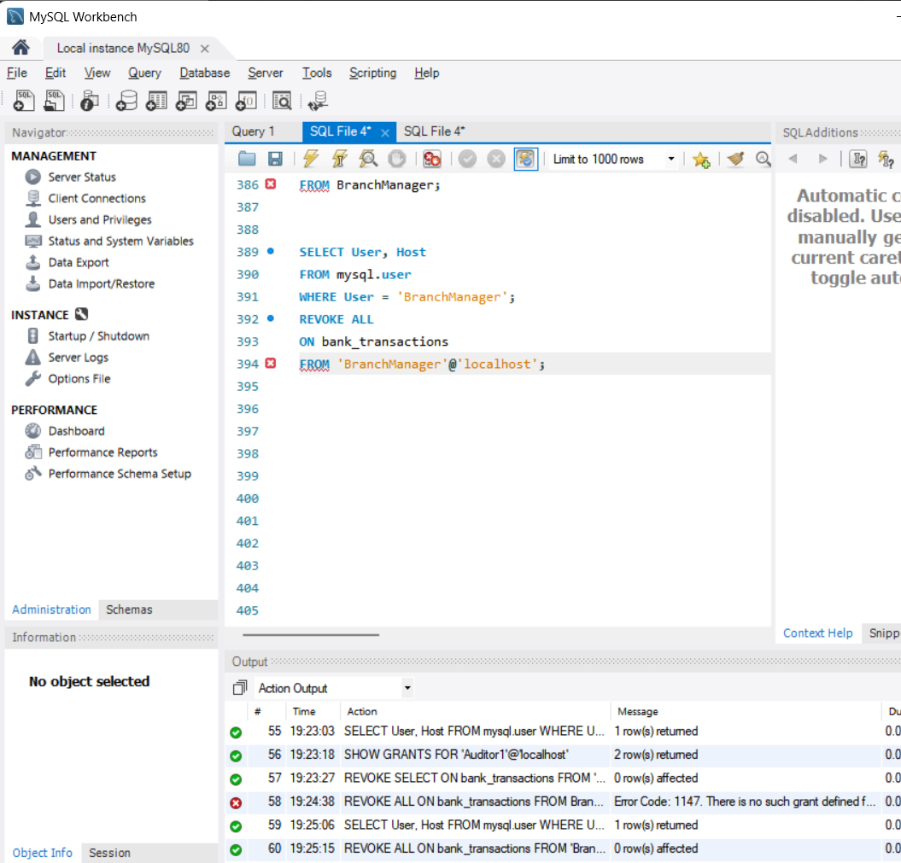

TCL[TRANSACTION CONTROL LANGUAGE]
1.COMMIT
101 id deposite amount is updated from 5000 to 6000
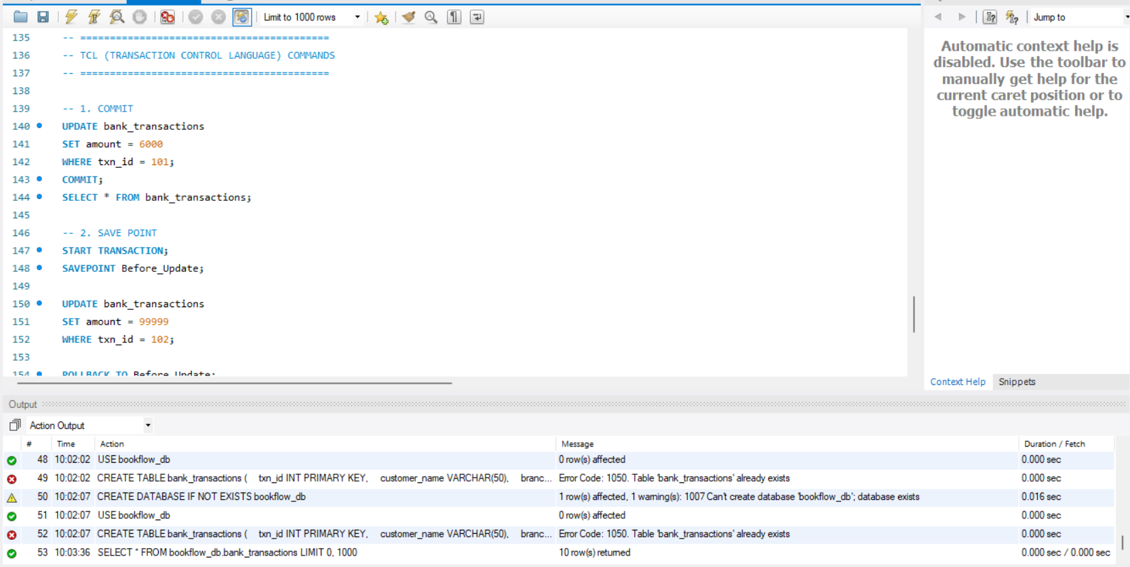

2.SAVE POINT
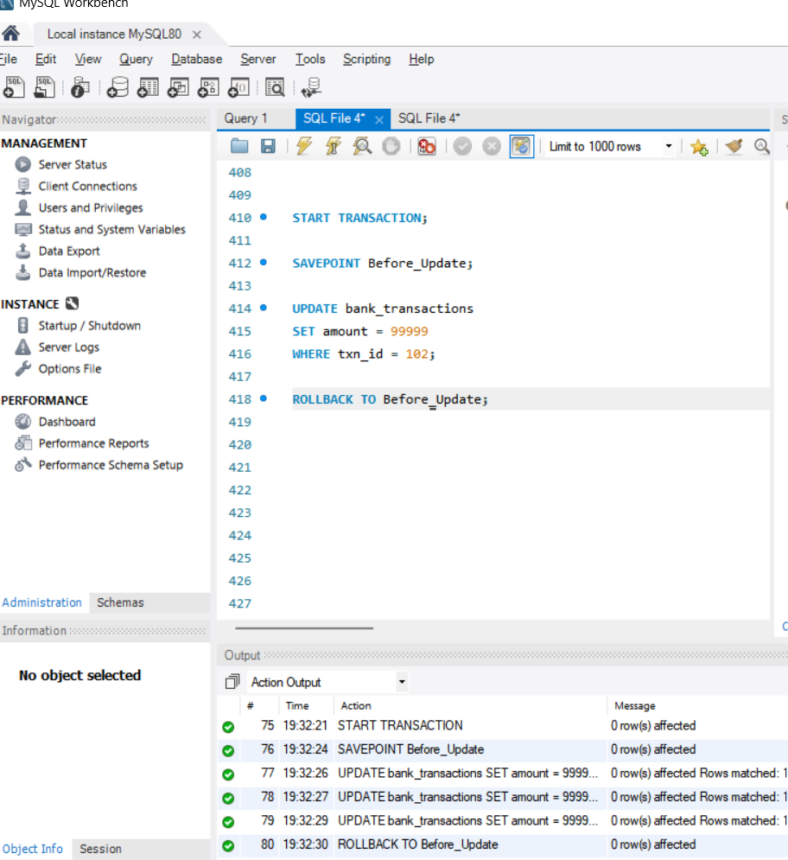

3.FULL TCL EXAMPLE
